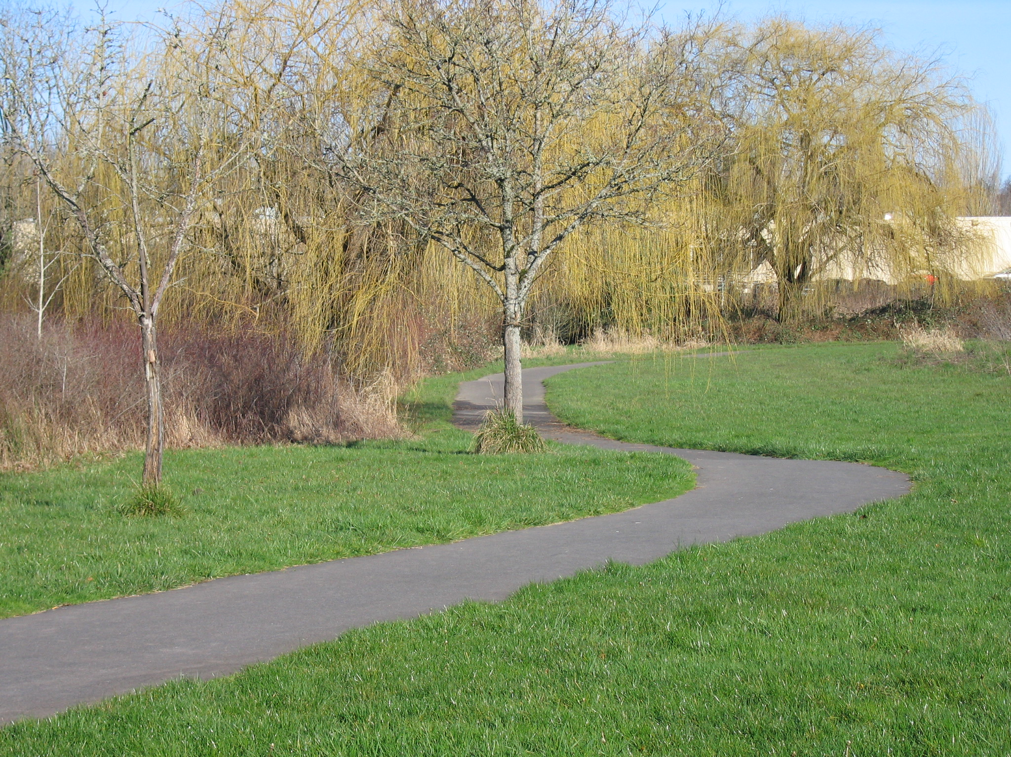
Trails Advisory Committee
Tuesday, April 17, 2012 7:00 PM
Fanno Creek Service Center-Sequoia Room
6220 SW 112th Ave
Beaverton, OR 97008

AGENDA

- Welcome

- Introduction of Guests/Visitors

- Approval of March meeting minutes and Volunteer Hours for March

- Announcements

- Aloha-Reedville Study & Livability Community Plan Mike Dahlstrom Project Manager

- Trail Counters Scott Hinderman

- Upper Fanno Creek Trail Improvements Update Tom

- Use of Challenge Grant Funds Steve

- Westside Regional Trail Master Plan Committee Report Joe

- Update: 2012 Committee Calendar Tom

- Staff Update on Trail Projects Steve
  - Bond Measure Trails Update
    - Westside Trail
    - Waterhouse Trail
    - Rock Creek
    - N. Bethany
  - MTIP Funding
    - Fanno Creek Trail/Hall Blvd Feasibility Study
    - Westside Trail Segment #18
- Detailed Updates: Washington County, City of Beaverton, Beaverton School District, COB BAC, Metro
- Open Discussion (Time Permitting) Whole Committee

Next Meeting: April 17, 2012

