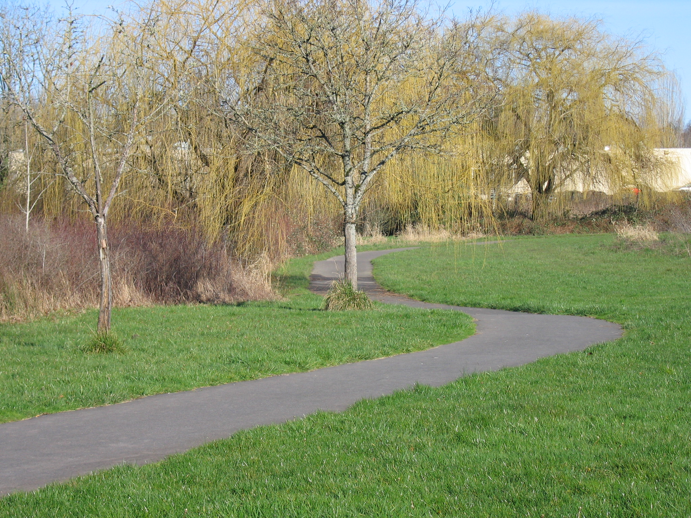
Trails Advisory Committee
Tuesday, June 19, 2012 7:00 PM
Fanno Creek Service Center
Main Conference Room
6220 SW 112th Ave
Beaverton, OR 97006

AGENDA

- Welcome

- Introduction of Guests/Visitors
- Approval of May Meeting Minutes and Volunteer Hours May

- Announcements

- Westside to Waterhouse Trail Connection Rene’ Brucker

- Soft Surface Running Track Along Rock Creek Trail Bruce Barbarasch
- Upper Fanno Creek Trail Improvements, Update Bruce and Tom
- Application For Membership In Trails Advisory Committee Steve
- Plan of Action for Committee Members Attending Public Meetings Barb and Steve
- Westside Regional Trail Master Plan Committee, Report Joe

- 2012 Committee Calendar, Update (Including Picnic) Mary and Tom

- Update Trail Projects Steve
  - Bond Measure Trails Update
    - Westside Trail
    - Waterhouse Trail
    - Rock Creek Trail
  - MTIP Funding
    - Fanno Creek Trail/Hall Blvd Feasibility Study
    - Westside Trail Segment #18
- Detailed Updates: Washington County, City of Beaverton, Beaverton School District, COB BAC, Metro

Next Meeting (Picnic at Jenkins Estate-Camp Rivendale): July 17, 2012

