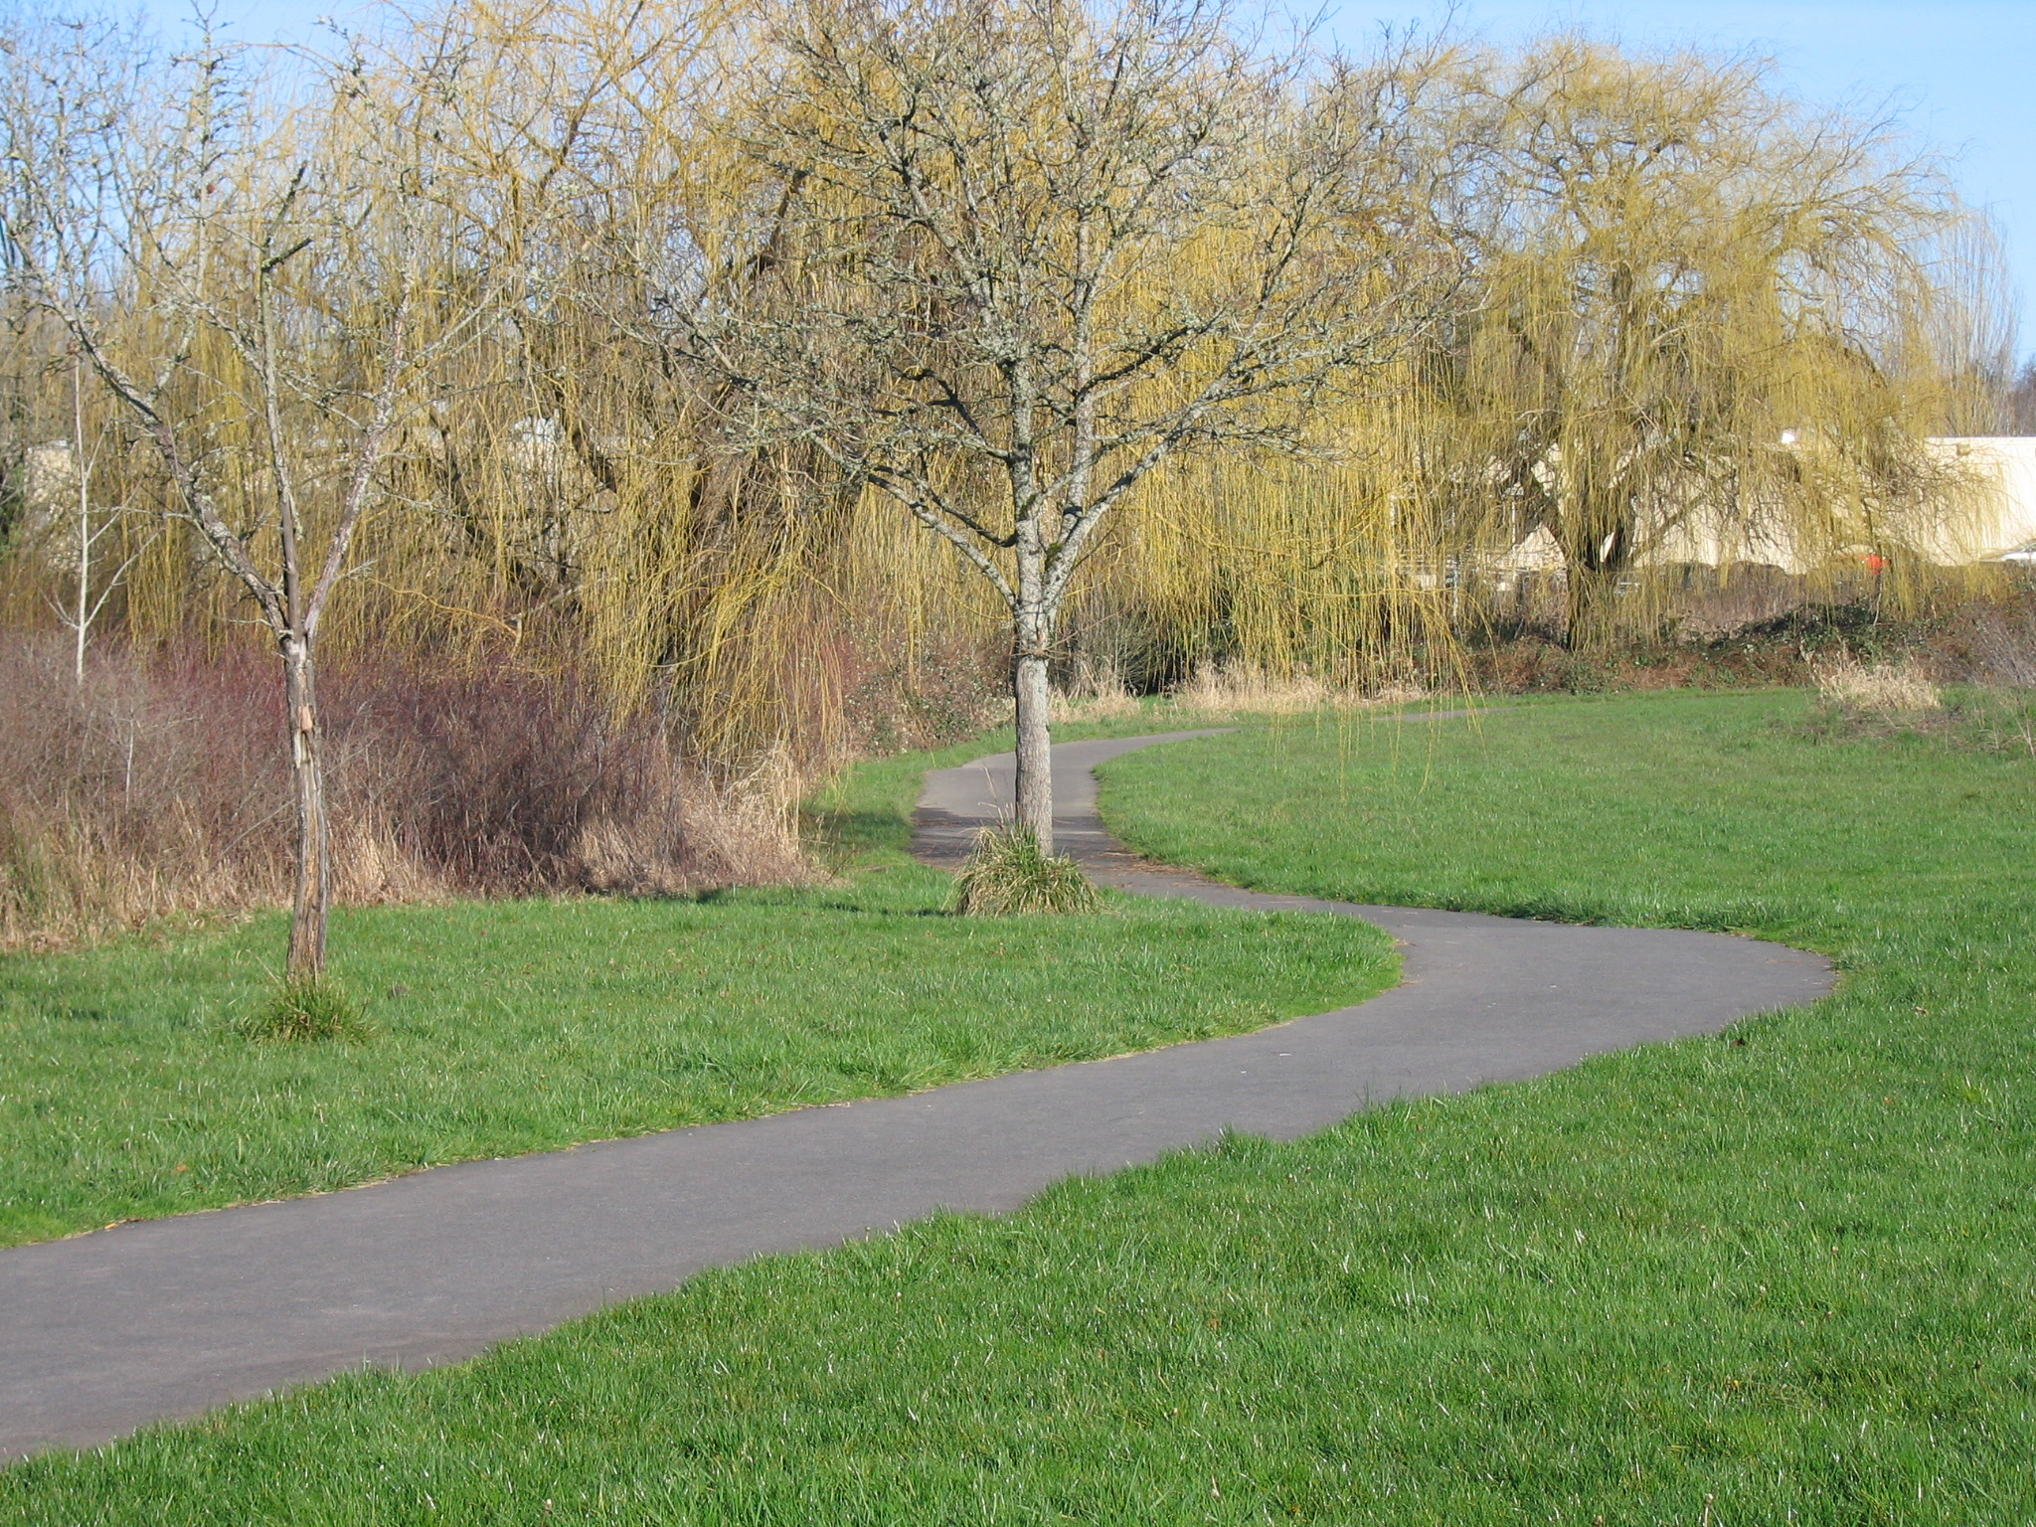
Trails Advisory Committee
Tuesday, July 17, 2012 6:00 PM
Annual Picnic Meeting
Camp Rivendale at
The Jenkins Estate
8385 SW Grabhorn Rd
(2nd Iron Gate up hill)
Beaverton, OR, 97007

AGENDA

- Welcome

- Introduction of Guests/Visitors
- Approval of June Meeting Minutes and Volunteer Hours June

- Announcements

- Presentation: Willamette Pedestrian Coalition Stephanie Routh

- Other Business

- Adjourn

ENJOY

Next Meeting (Field Trip To Construction Sites): August 20, 2012

