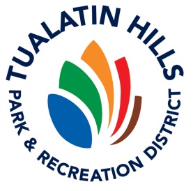
How to Report
An Injury while Volunteering

Our goal is for you to have a safe and healthy experience while volunteering. If you experience an injury while performing your volunteer duties, we need to know, so here are the steps to follow if you’re injured.
- Assess the situation and/or your injury. Call 911 if necessary. If possible, move to a safer location and/or the trailhead in the park, so emergency services can more easily find you. If you are unable to move and have called 911, try to flag down another person who can meet emergency responders and direct them to your location.
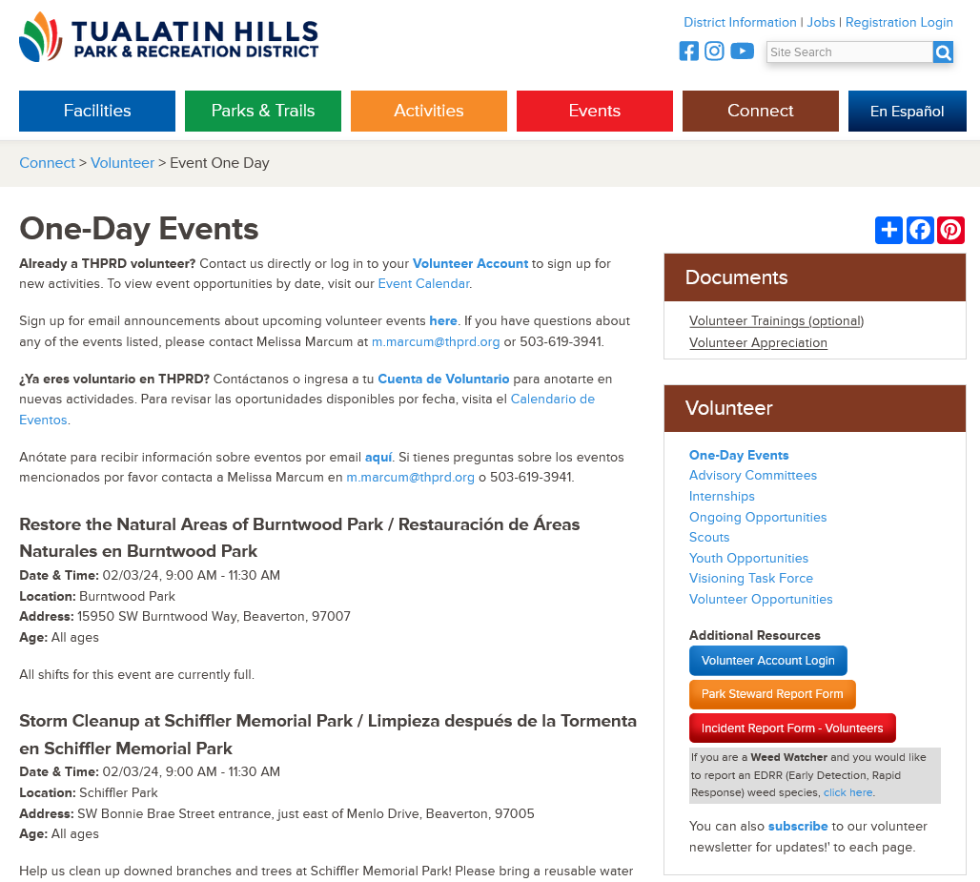
- Please use a first aid kit to treat yourself, if available. If you are a minor, please check in with your parent/guardian about your injury before treatment.

- At your earliest convenience, please notify Melissa Marcum of your injury at m.marcum@thprd.org.

- When you are finished at the site, go to www.thprd.org/volunteer and scroll down until you see the big red button on the right side of the page, labeled ‘Incident Report Form – Volunteers’.

- Please complete this form ASAP. Upon completion, THPRD will receive notification of your injury, with the context necessary to follow up with you about your injury.

